



ROUTE 25 - November

Ricardo Abreu

**14.11.2025**

8.11 November 2025

**Code available at:** [ricardo-abreu1/Route-25](https://github.com/ricardo-abreu1/Route-25)

8.11.1 Technical Activity – QoS Prediction Model Development

# **Change History**

|  |  |  |  |
| --- | --- | --- | --- |
| **Date** | **Version** | **Author** | **Description** |
| 11/11/2025 | 1 | Ricardo Abreu | Onboarding, 8.11.1 - Explorating QWS dataset |
| 12/11/2025 | 2 | Ricardo Abreu | 8.11.1 - Data Exploratory Analysis, Data Processed. Implemented LinReg, Random Forest and XGBoost |
| 13/11/2025 | 3 | Ricardo Abreu | 8.11.1 - Data Profiling, Exploratory Analysis, Data Processed (scripts improvements) |
| 14/11/2025 | 4 | Ricardo Abreu | 8-11-1 - Models Tuning and Evaluation |

**Table of Contents**

Contents

Change History 2

Week 1 4

Week 2 20

# Week 1

Load and Inspect Data sources – Dataset “QWS Dataset V1”

The data source was in **.txt format** and contained comments and non-standard headers, which required initial cleaning. In this first step, a copy of the file was created, and the first 42 lines—containing only the project description—were removed. Next, a header row with column names was added to match the data structure. The file was then loaded into the local environment for data analysis.

The next phase consisted of **exploratory data analysis** to gain a deep understanding of the data, metadata, and dataset structure.

After that, the data was inspected for **null values, duplicates, and outliers**, following standard procedures for dataset profiling.

As a final note for this stage, the following points were observed:

1. Data types are correct;
2. The dataset contains no duplicates or null values;
3. The dataset includes some outliers; however, given its small size, these were retained.
4. The target variable chosen for prediction is **“WsRF: Web Service Relevancy Function (%)”**.

In this phase, a **graphical analysis** was performed to better understand the data distribution and relationships between variables.  
Univariate, bivariate, and multivariate analyses were conducted, considering service classification into predefined categories.

Initially, the variables **“Response Time”** and **“Latency”** were explored due to their less symmetric distributions.

Subsequently, the remaining numeric variables were analyzed according to their distribution.

The next step involved creating a **correlation matrix** during the bivariate analysis to identify patterns among variables.

Below is an example of a chart illustrating the decision to drop a variable from the model because it showed no meaningful pattern with the target variable.

Finally, a brief multivariate analysis was performed to understand how certain characteristics relate to service level.

Key findings from this analysis:

* Univariate Analysis:
  + Availability is concentrated near 100%, suggesting most services are highly available.
  + Successability, Reliability, and WsRF are fairly normal, centered around 50–80.
* Bivariate Analysis:
  + Platinum services (Class 1) generally have lower Response Time and Latency compared to Bronze.
  + Throughput tends to decrease as class level increases (Platinum → Bronze).
  + Reliability and Successability are higher for Platinum and Gold.
  + Response Time and Latency show strong positive correlation (services with high response time also have high latency).
  + Best Practices vs WsRF shows weak correlation, suggesting WsRF may not strongly depend on Best Practices.
  + Response Time and Latency have the highest correlation among numeric features.
  + Availability and Documentation have low correlation with other metrics, indicating limited predictive power.
* Multivariate Analysis:
  + Platinum services cluster with low Response Time and Latency, high Reliability and Successability.
  + Bronze services show the opposite pattern: high delays and lower reliability.
  + Columns that can be dropped - (Latency or Response Time, only one) and Best Practices.

Machine Learning model making:

In this phase, **Machine Learning (ML) models** were built to train on the data and predict future datasets.  
The workflow followed this sequence:

1. Split the data into training and test sets.
2. Define preprocessing steps. For the Linear Regression model, the data suffers an additional step of “scaling“ so that the features had a similar distribution.
3. Train the model using the training set.
4. Evaluate the model on the test set.
5. Tune the model (an iterative process to identify the best parameters for improved performance).

Data Splitting:

The figure below illustrates how data was split and columns with low correlation were removed (to reduce noise in the model).

Next, a **baseline model** was defined for comparison with subsequent models. There is 2 ways to do this. The first picture shows the manual way to compute metrics for the baseline model and the second figure shows how to do it according to scikit-learn.

The models selected were **Linear Regression, Random Forest, and XGBoost**.

The following table shows the results of 3 metrics for all 3 models:

|  |  |  |  |
| --- | --- | --- | --- |
| Model | RMSE | MAE | R2 |
| Linear Regression | 3.5986977509976765 | 2.6328531950906426 | 0.927806724857026 |
| Random Forest | 3.8037618366018973 | 2.5113698630136994 | 0.9193447515586426 |
| XGBoost | 3.8115673065185547 | 2.6854708194732666 | 0.9190133810043335 |

Confidence Interval

A confidence interval gives a range of values that likely contains the true metric for the model, based on testing data. For it was applied boostrapping. Bootstrapping simulates many possible test sets by resampling testing data.

**1. Linear Regression** (benefits greatly from more data, overfitting is evident at small sample sizes)

    - Train RMSE (blue): Starts near zero and stays extremely low across all training sizes.

    - The model fits training data almost perfectly, which is expected for linear regression on small datasets.

    - CV RMSE (orange): Starts very high (~193) with small training size, then drops sharply to ~3.3 at full size.

    - Gap between train and CV RMSE at small sizes > severe overfitting initially.

    - Trend: As training size increases, CV RMSE decreases and stabilizes but never meets train RMSE.

**2. Random Forest** (highly flexible and overfits small datasets, dding data improves CV RMSE but gap persists)

    - Train RMSE (blue): Very low (~1.5) and flat across all sizes > model memorizes training data.

    - CV RMSE (orange): Starts at ~20.6, decreases gradually to ~6.0 at full size.

    - Shaded region: Wide at small sizes, narrows as size grows > variance reduces with more data.

**3. XGBoost** (Overfits small datasets, Still needs regularization or more data to close the gap)

    - Train RMSE (blue): Near zero across all sizes > extreme memorization.

    - CV RMSE (orange): Starts at ~19.2, drops to ~6.0, overfitting similar to Random Forest but better CV RMSE at mid-range sizes.

    - Variance: High at small sizes, narrows with more data.

Model Tuning - RandomizedSearchCV

Nesta secção é descrito como os modelos foram melhorados. Cada modelo tem um algoritmo com hyper-parâmetros (parâmetros do algoritmo) que podem ser modificados no sentido de melhorar a performance por parte do modelo de ML. Segue o exemplo abaixo para descrever parâmetros que podem ser mudados na Regressão Linear:

Eg. Hyperparameters for Linear Regression:

* - fit_intercept: Whether to calculate the intercept (True/False).
* - positive: Force coefficients to be positive (True/False).
* - normalize: Deprecated in newer versions (use StandardScaler instead).
* - n_jobs: For parallel computation (usually not critical here)

Afterwards, the train data was fed into the models to predict values.

After calling the function to predict the values, all of the aspects related to evaluating the models were made.

Then it was produced a sample of the dataframe with actual values and the ones predicted by each model.

Afterwards, all metrics of all models were graphically put together for visibility,

* **RMSE (Root Mean Squared Error):** Measures prediction error magnitude. Lower is better.
* **MAE (Mean Absolute Error):** Measures average absolute deviation. Useful for interpretability.
* **R² (Coefficient of Determination):** Indicates how much variance in the target is explained by the model. Closer to 1 means better fit.

Then, the results from the tuning of the models, the results from the models there were not tuned and the baseline model were compared, as showed in the previous picture. It’s results are in the following table:

|  |  |  |  |
| --- | --- | --- | --- |
| Model | RMSE | MAE | R2 |
| Baseline | 13.408000765060446 | 10.687379372028431 | -0.002153048229032839 |
| Linear Regression | 3.5986977509976765 | 2.6328531950906426 | 0.927806724857026 |
| Random Forest | 3.8037618366018973 | 2.5113698630136994 | 0.9193447515586426 |
| XGBoost | 3.8115673065185547 | 2.6854708194732666 | 0.9190133810043335 |
| Linear Regression (tuned) | 3.5986977509976765 | 2.6328531950906426 | 0.927806724857026 |
| Random Forest (tuned) | 3.8263169789963936 | 2.513851973011654 | 0.918385393789493 |
| XGBoost (tuned) | 2.7543282508850098 | 1.8014215230941772 | 0.9577100276947021 |

This next code block produced the following:

**For the Residual Plot (Predicted vs Residuals):**

* Centering around zero: Most residuals cluster near the red line (0), which is good — predictions are generally unbiased.
* Spread increases slightly for higher predicted values: At predicted values above ~75, residuals become more positive and more variable.
* This suggests mild heteroscedasticity (variance of errors grows with predicted value).
* Outliers: There are a few large positive residuals (up to ~15), meaning the model underpredicted those cases significantly.

**Residual Distribution (Histogram):**

* Shape: Mostly bell-shaped and centered near zero, which is ideal for regression assumptions.
* Slight right skew: A tail toward positive residuals indicates some cases where the model underestimates the target.
* No severe multimodality: No clear clusters, so the model likely captures the main pattern well.

**QQ plot:**

The following picture shows the code block for the QQ Plot.

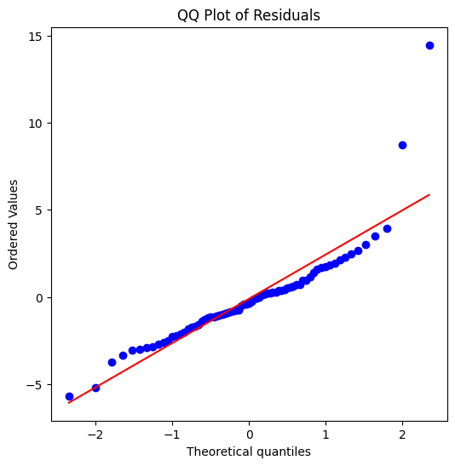

Central Alignment:

* Most points lie close to the red line in the center, meaning residuals are approximately normal for the bulk of the data.

Heavy Right Tail (Positive Outliers):

* The top-right points deviate strongly from the line, especially two extreme points around 9 and 15.
* This indicates large positive residuals. Model underpredicted these observations significantly (normal because since the amount of data is small the outliers were kept)

Slight Left Tail Deviation:

* Bottom-left points also deviate, but less severely than the right tail.
* Suggests some negative outliers (overpredictions), but not as extreme.

Feature Importance (Regression models):

In this section it’s described the steps to find the importance of the features for each model. So, the next 2 figures explain how this was done, and then presented a table with the features and their respective importance for the models ordered by the Linear Regression Ranking.

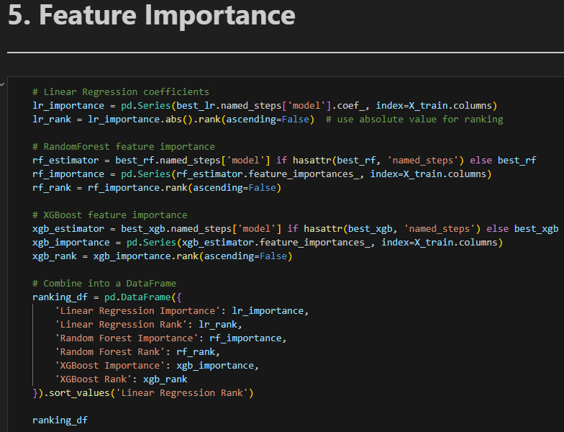

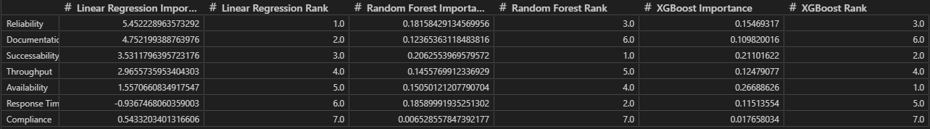

# Week 2

To finish the script of the regression models, a final graph was constructed showing the features importances according to a Shap graph for the model with the best results which was XGBoost.

Finally, the models were exported, with all the metrics for evaluation for json and csv format, and also a md file was created depicting at a high level the model and its metrics as showed in the following figures.

Classification Models

To construct a script for a categorical model, the process is almost the same as the regression, so the script follows almost the same structure. One of the key differences in this script is that the label (target value) which currently is a class between 1 through 4 already in the datatype integer). In this example it is not necessary but for consistency it suffered a process of encodement just in case any data was different than integer. Then this column fits these values and assigns values from 0 through 3, this is important because some ML Models work with 0 as a starting point.

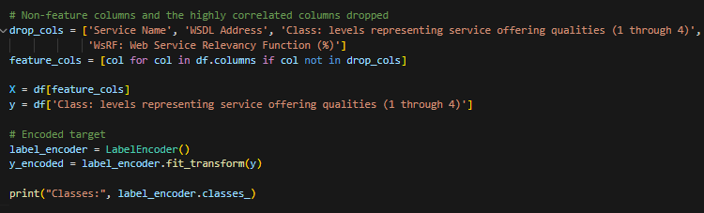

Then a baseline model was established to predict the most frequent class.

Just to have an idea of the predicted values of the classification models chosen, the following pipeline was constructed, and the values are in the following figures.

Following the same procedure for the regression models, these were evaluated according to 5 of the following metrics.

These next sections are for the tuning of hyperparameters for all models.

After tunning the models, by settings hyperparameters that influence the model, a cross-validation was made to identify the best model overall based on F1 metric.

For results, it was shown the best model was the tuned Logistic Regression the following details:

* Accuracy (0.8405 ± 0.0543) -> The model correctly predicts about 84% of cases on average. The ±0.05 shows moderate variability across folds, which is acceptable for this dataset size.
* Precision_macro (0.8438) -> When the model predicts a class, it is correct 84% of the time on average across all classes, indicating reliable predictions.
* Recall_macro (0.8549) -> The model captures about 85% of actual cases, showing strong sensitivity and ability to identify true positives.
* F1_macro (0.8469 ± 0.0506) -> A balanced measure of precision and recall. At ~85%, the model demonstrates excellent overall performance.
* ROC_AUC_OVR (0.9669) -> Outstanding ability to separate classes (close to 1.0). This suggests the model is highly effective at distinguishing between different service quality levels.

In these 2 next figures, it’s showed an example of predicted values by every model and the actual values and the metrics for all models respectively.

It is important to note that, in each day the code was reviewed and optimized some sections according not only to the current task but also for future ones. Nontheless in this report it’s showed everything for transparency and to show the progress of the author.

As the regression model, it was made a graph with a learning curve for the tuned logistic regression classification model.

The learning curve illustrates how the F1 score (macro) evolves as the training set size increases:

* Initial Phase (≈94 samples): The training score starts very high (≈0.95), while the validation score is low (≈0.34). This large gap indicates strong overfitting when the model is trained on a small dataset — it memorizes the training data but fails to generalize.
* Intermediate Phase (≈160–225 samples): As more data is added, the validation score improves significantly (rising to ≈0.82), while the training score decreases slightly (≈0.81). This convergence suggests the model is learning more generalizable patterns and reducing overfitting.
* Final Phase (≈291 samples): Both curves stabilize close together (training ≈0.90, validation ≈0.85). The small remaining gap indicates mild overfitting, which is expected given the limited dataset size. The plateau in the validation curve suggests that adding more data may yield only marginal improvements unless combined with feature engineering or regularization adjustments.
* Confidence Intervals: The shaded regions show variability across folds. Wider intervals at smaller training sizes reflect instability due to limited data, while narrower intervals at larger sizes indicate more consistent performance.

After this, confusing matrixes were constructed to further evaluate the values predicted and the actual values of the test dataset.

After this, confusing matrixes were constructed to further evaluate the values predicted and the actual values of the test dataset.

Each confusion matrix shows actual values vs predicted classes. The left matrix displays raw counts, while the right matrix shows percentages normalized per actual class. This helps identify which classes are predicted accurately and where misclassifications occur relative to class size.

Following the same analysis of the previous type of models (regression), a feature importance analysis was made for all tuned classification models.

**1) Random Forest Tuned Importance:**

    - Top Feature: Reliability is the most influential feature, indicating that service reliability strongly impacts the predicted quality level.

    - Other High-Impact Features: Throughput and Successability follow closely, suggesting performance and success rate are critical.

    - Moderate Importance: Documentation and Response Time still play a role but less than reliability.

    - Least Important: Compliance and Best Practices have minimal impact, meaning they contribute little to prediction accuracy.

**2) XGBoost Tuned Importance:**

    - Top Feature: Availability dominates, showing that uptime is the strongest predictor for XGBoost.

    - Balanced Importance: Reliability, Successability, and Throughput are all significant, reinforcing the importance of performance metrics.

    - Moderate Role: Documentation and Response Time are secondary factors.

    - Least Important: Compliance and Best Practices remain low, similar to Random Forest.

**3) Logistic Regression Importance:**

    - Top Feature: Latency has the highest coefficient magnitude, meaning delays strongly influence the predicted class.

    - Second Strongest: Response Time also matters significantly.

    - Moderate Impact: Reliability and Documentation contribute meaningfully.

    - Low Impact: Best Practices and Compliance have very small coefficients, confirming their limited predictive power.

**Overall:**

- Across all models, features tied to speed (Latency, Response Time) and stability (Reliability, Availability) consistently rank high.

- Documentation is Secondary: While not negligible, documentation is less critical than technical performance.

- Compliance & Best Practices Are Weak Predictors consistently rank lowest, suggesting they do not strongly differentiate service quality levels.

After this a SHAP graph was made for all tuned models as per identified in the following pictures.

**Top Influential Features Across Models:**

* Response Time and Successability consistently show the strongest impact on predictions.
* Throughput and Availability also contribute but to a lesser extent.
* Interaction Effects: SHAP interaction plots indicate weak feature interactions overall, meaning predictions rely on combined effects rather than a single dominant feature.

**Model-Specific Observations:**

* Random Forest and XGBoost emphasize performance and reliability metrics.
* Logistic Regression highlights latency-related features (e.g., Response Time).

Interpretability Insight: No single feature overwhelmingly drives predictions; instead, multiple features collectively influence the outcome, reinforcing the need for a balanced feature set.

To end the classification models for the first task, the best model was exported with all metrics into a json and csv file, and also a md file was constructed following the same procedure as the regression models.

About Capgemini Engineering

World leader in engineering and R&D services, Capgemini Engineering combines its broad industry knowledge and cutting-edge technologies in digital and software to support the convergence of the physical and digital worlds. Coupled with the capabilities of the rest of the Group, it helps clients to accelerate their journey towards Intelligent Industry. Capgemini Engineering has 65,000 engineer and scientist team members in over 30 countries across sectors including Aeronautics, Space, Defense, Naval, Automotive, Rail, Infrastructure & Transportation, Energy, Utilities & Chemicals, Life Sciences, Communications, Semiconductor & Electronics, Industrial & Consumer, Software & Internet.

Capgemini Engineering is an integral part of the Capgemini Group, a global business and technology transformation partner, helping organizations to accelerate their dual transition to a digital and sustainable world, while creating tangible impact for enterprises and society. It is a responsible and diverse group of 340,000 team members in more than 50 countries. With its strong over 55-year heritage, Capgemini is trusted by its clients to unlock the value of technology to address the entire breadth of their business needs. It delivers end-to-end services and solutions leveraging strengths from strategy and design to engineering, all fueled by its market leading capabilities in AI, cloud and data, combined with its deep industry expertise and partner ecosystem. The Group reported 2023 global revenues of €22.5 billion.

Get the future you want | [www.capgemini.com](https://www.capgemini.com)

[](https://de-de.facebook.com/Capgemini) [](http://www.linkedin.com/company/capgemini) [](http://www.slideshare.net/capgemini) [](http://www.youtube.com/capgeminimedia)

This presentation contains information that may be privileged or   
confidential and is the property of the Capgemini Group.

Copyright © 2024 Capgemini. All rights reserved.